Purpose of this report.

The purposed of this report is to document the results of the Future Finderne Community Survey, that took place in September and October 2024.

Background

The Finderne Community Council has undertaken a survey, in order to get community input for the Local Place Plan that will be submitted to the Moray Council.

Local Place Plans are developed by communities and are used by the Local Authority in creating their Local Development Plan, which includes planning guidelines for how and where land and property will be developed.

Paper copies of the survey were sent by post to all 509 households in Finderne in mid September 2024 , and an on line version of the survey was also launched. Responses were due by 8th October, and were used to develop the presentation boards used a the Drop-in events in Edinkiike and Rafford on 29th and 30th October.

Design and implementation of the survey was assisted by the Finderne Development Trust and Collective Architecture.

Survey Topics

- Housing
- Windfarms
- Broadband
- Road Safety
- Community Hubs
- Active Travel
- Open Spaces

Survey Results

74 responses were received by the end of the survey period, representing a 15% response rate. For response rate by Area and Locality see appendix 1.

The results for each topic a presented on the following pages.

Where comments were asked for, Common Themes have been presented within each topic, and a full list of responses is included in the appendices.

Housing

Q: Is additional housing needed in Finderne?
A: Roughly 50:50 No:Yes, but some key differences by area, as highlighted below.

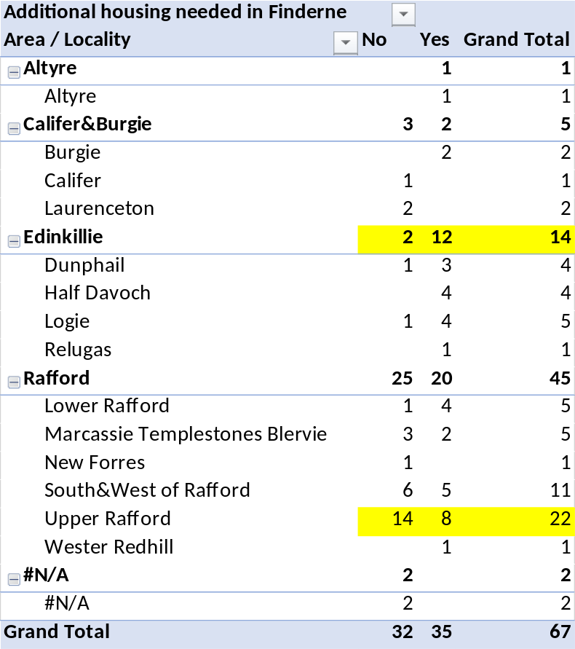

Q: Housing – IF it is to be built, what type and where?

A: Significant majority in favour of Smaller, more affordable home within existing villages or clusters.

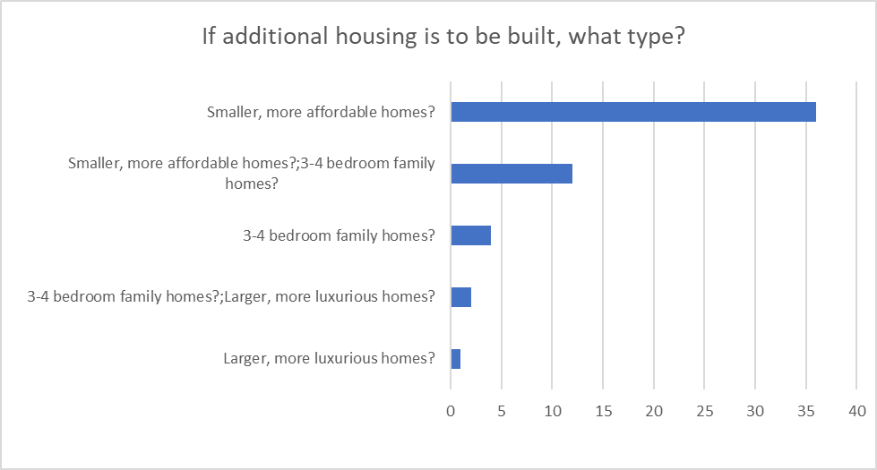

Housing Comments: Common Themes – Housing Location

- Near to Logie School/Edinkillie Hall is most frequent
- Near Services and School and Brownfield sites feature strongly.
- In Rafford / not Rafford cancel each other out?
- Nowhere in Finderne reflect those who want no housing

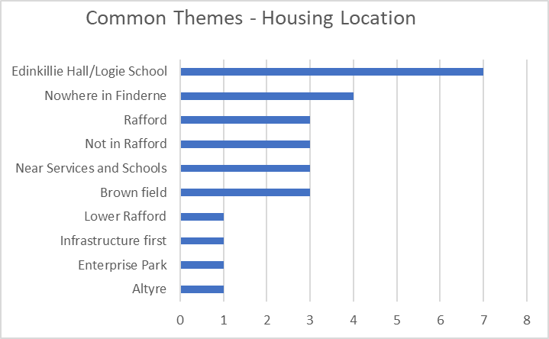

Question: Any further comments on Housing?
- The Need for Infrastucture & Services, (Doctors, Shops, Schools, safer roads, drainage) features most strongly
- Affordable Housing seems to the next most important theme

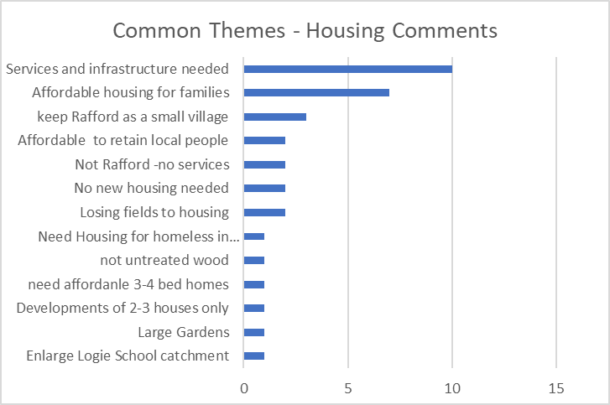
Renewables – Windfarms etc.

There are a number of windfarm and renewable energy, development within Finderne. FCC focus is to maximise benefit to the community while minimizing the impact of these developments.
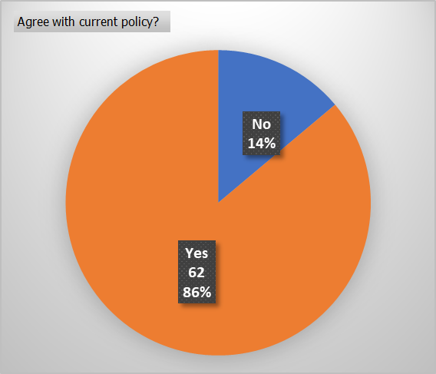
Question: Do you agree with this current policy?

Answer . . . .

Question: Any other comments on Windfarms Pylons, or Energy Storage?

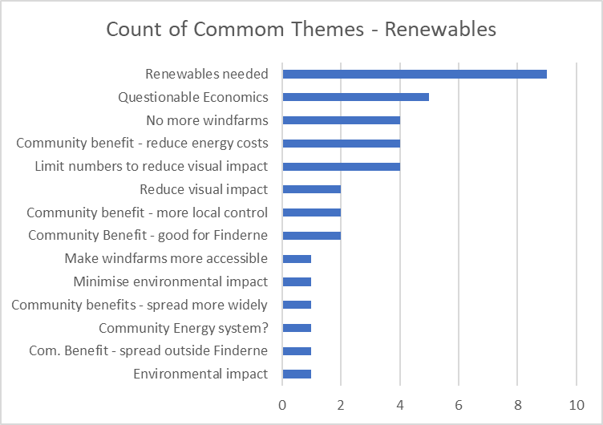

Broadband

FCC plan to include the need for Superfast Broadband to be available throughout the whole of Finderne.

Question: Do you agree?

Answer: 99% responded and 99% of responses agreed.

Question: Any other Comments on Broadband?

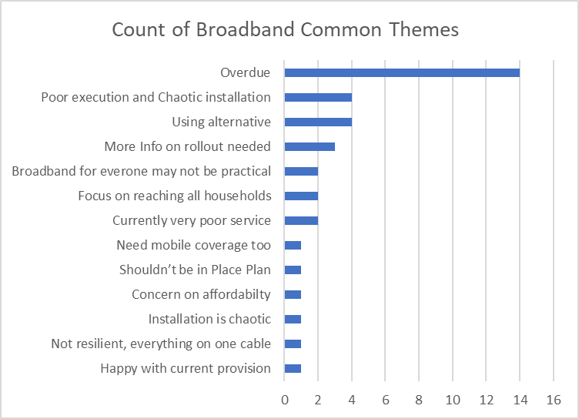

Road Safety

FCC are actively promoting speed management within residential communities.

Question: What else could be done to improve Road Safety in Finderne?

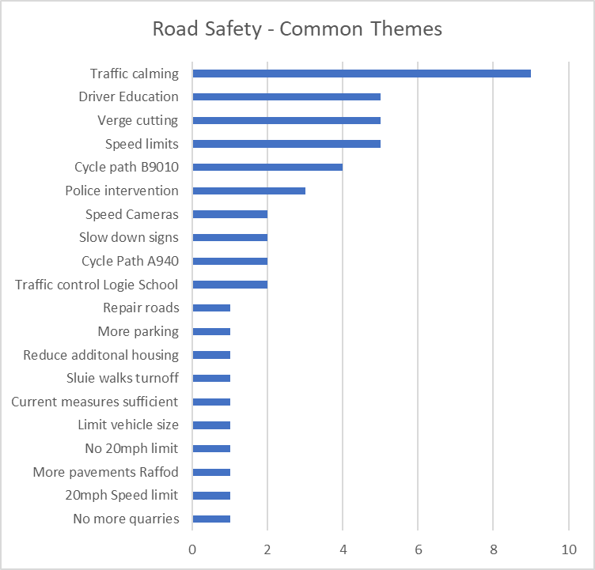

Community Hubs

Question: Do you make use of your local village hall?

Answer: 75% of responses say “Yes”.

Question: How often?

Answer:
- Rafford Average 20 times per year
- Edinkillie Average 5 times per year.
This reflects the larger community in the Rafford Area generating more activities in the village hall.

Question: What improvements would you like to see in your local village hall?
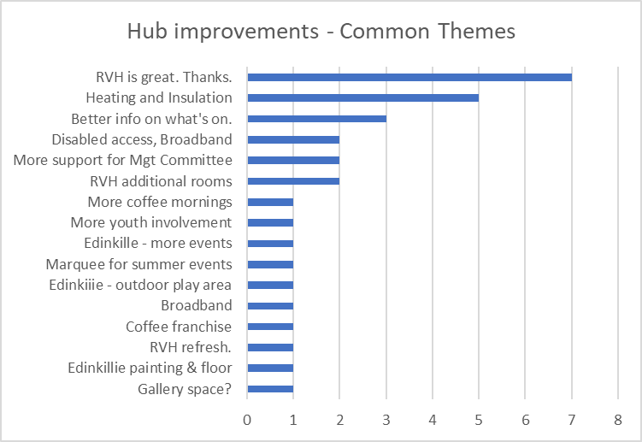

Question: What underused or disused building could be brought into use, and for what purposes:

Answers: What Buildings
- Rafford and Edinlillie Churches were mentioned very frequently.
- Leanchoil Hospital and Upstairs at Rafford Village Hall were mentioned.
- There were a couple of comments concerned about funding and community support for any further developments.
Answers: What Purpose
A large range of purposes including:
- Recreation space, Café,
- Arts and Crafts, Gallery or Performance Space
- Working spaces and additional meeting rooms
Active Travel

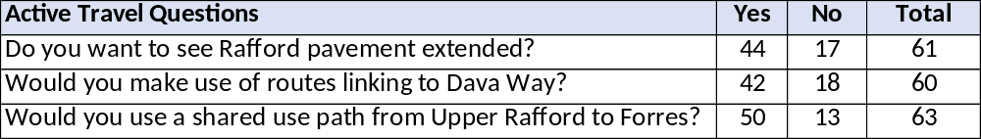

Question: Any Other Areas where pedestrian and cycling improvements could be make?

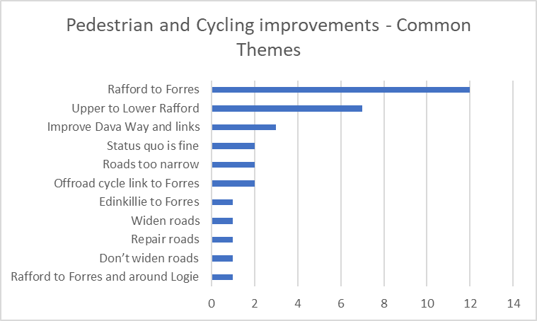

Question: Any further suggestions on Active Travel

Answers: Many and varied See Appendix 7

Open Spaces

Question: Do you think existing play areas should be preserved and maintained?

Answer: Unsurprisingly, all 69 responses to this questions said “Yes”.

Question: Do we need additional paly areas or sports field in Finderne?

Question: Any other uses of Opens Spaces which should be included in LPP?

Answers: Developing Playing field and play areas at both Rafford and Edinkillie Halls was the biggest common theme. For other ideas see appendix.

Question: Please identify areas of natural habitat/biodiversity or of historical interest in Finderne that should be preserved or nominated for conservation status?

Answers: Many ideas including:

- Rafford and Edinkillie Churches
- Preserve all our countryside, woodlands and wildlife
- Blairs Loch, Randolfs Leap, Blervie Castle, Relugas and Burgie Castles
- Findhorn and Divie Gorges, Dava Way, Dava Moor
- Avoid disturbing wildlife, stick to main routes
- Preserve ancient rights of way and military roads

For details see Appendix 8.
Appendix 1 - Response Rate by Area and Locality

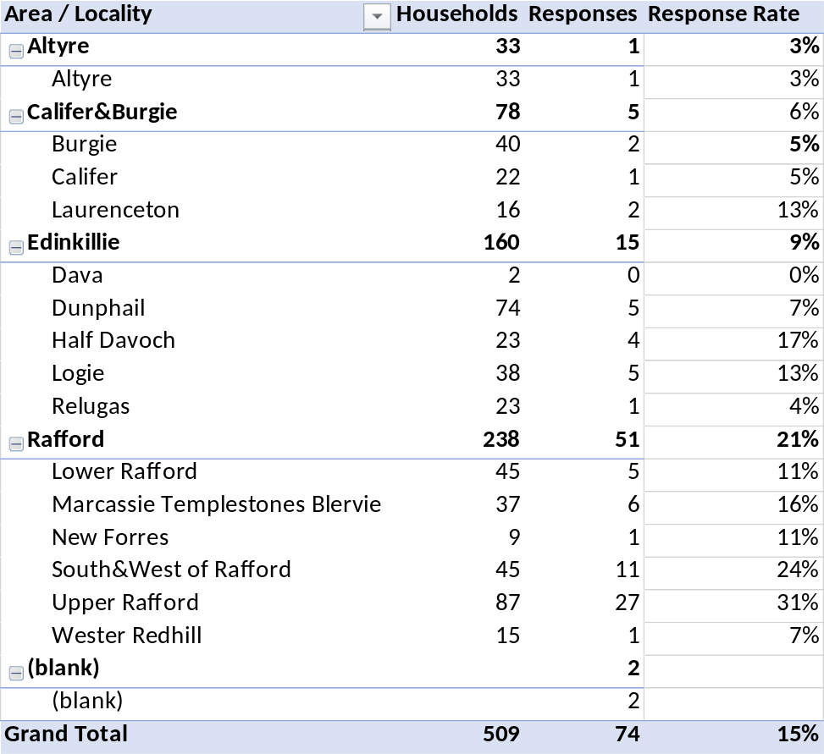
Appendix 2 - Housing Detail Responses

Do you have any suggestions for potential locations for new housing?

Anywhere but Finderne area
not in my village Rafford
No housing needed. Far too many houses in Forres, many of them adjoining Finderne. Beautiful countryside ruined.
Rafford, Dallas
BROWN FIELD ONLY
Iâ€™m not sure that small rural villages are the right place for development
Anywhere itâ€™s not going to annoy the neighbours.
Adjacent to Edinkillie Village Hall and Logie School
If Logie Primary School remains open, it would be great to have some housing within walking distance to the school.
Small space of land (about an acre) at the south side of lower Rafford (its within the settlement boundary of the local plan). Also some of the Church land (either side of the manse)
Infrastructure needs to be addressed before housing can be considered
Let people split their large plot, farm land within the existing built area.
Logie Primary School's catchment area
There is potential for new housing on the outskirts of the village at either end.
New housing should be located in close proximity to schools and other facilities and should avoid placing pressure on areas which would have difficulty coping with additional traffic
Logie school area, adjacent fields & woodlands.
PresleyFarm area
Edinkillie Hall / County Houses area
Village boundaries
Near Logie, in order to support the local school
Where residents have access to potential buss services to schools and shopping
None. the village should STAY a village
How about suing some of the unused sites at the Enterprise Park near Grange Hall
Outwith the above parameters any extra building would spoil the unique village and charms of Rafford
All brownfield sites including all disused churches which should be demolished as they are a huge cost to structurally maintain over the years
Can not comment on anything outwith my area, which has drainage problems already
Inverness, Nairn, Elgin.
Rafford should be a place that people can aspire to live in. Pointless for Social housing an no other services here.
Altyre Area
As near Hall/School as possible
use houses which are there
There is a heck of a lot more required than housing
Use all the old farm steadings that are no longer used. Force all estates to improve if necessary and rent out or sell any empty houses.
Near Schools and local services
Edinkillie, Dunphail
I suggest that new housing developments be concentrated in areas such as Forres, where infrastructure and amenities are already in place to support additional residents. Forres has ongoing and planned developments, such as the proposed 850 houses in the Lochyhill area, which are better suited to accommodate population growth. Focusing on such areas ensures that residents have access to essential services like shops, schools, healthcare, and reliable public transportation without overextending the resources of smaller villages like Rafford. With Moray having a projected population decrease of 2.6% over the next 10 years, additional house building seems perverse in the extreme, benefitting only house builders looking to capitalise on land traditionally used for farming (or land banking in the meantime) to the detriment of existing residents. Once this land is built upon it is gone for good, but the additional problems further house building bring last for ever. Furthermore, given that Moray has an ageing population and lacks significant major employersâ€”surely reducing the demand for new housingâ€”the push for additional housing developments seems extremely puzzling, especially considering the potential strain on services like Health and Social Care.

Any further comments on Housing?

Roads infrastructure needs improving, bigger health centre, better public transport
plenty of new houses being built in forres area who is buying them?
IF houses are to be built then they should be family homes in the Dunphail area. This could protect the future of Logie Primary School.
Impressed with plans so far from Finderne Development Trust. We need to build houses for families, and encourage younger people to live in this community.
Affordable rental housing, especially with regard to elderly and disabled tenants.
It seems who you know counts.
New housing should come with supporting services and amenities eg. Parking, health & care services
Infrastructure must be in place surely before any sites decided uponâ€¦.school places, doctors, dentists, shops, suitable roads etc
A mixture of affordable housing, available for rent and purchase, shared equity etc would be good to help give young families an opportunity to raise their children in the countryside.
I think the affordable housing development and proposals for upper Rafford look great and looking forward to seeing it get built and families moving in
There is sufficient housing in this area
There appears to be a good steady turnover of housing stock in the locality. New houses are built. I see privately owned houses sell quickly and houses for rent are never empty for long.
I have several significant concerns regarding additional housing developments in Rafford:
1. Lack of Local Amenities and Infrastructureâ€¨: Rafford currently lacks essential amenities to support an increased population:
â—¦ No Local Shop: Residents must travel to Forres for basic necessities, increasing reliance on private vehicles and contributing to traffic and environmental impact.â€¨
â—¦ Limited Public Transport: The absence of a reliable bus service means residents depend on cars, which is not sustainable and may exclude those without access to private transportation.â€¨
â—¦ Existing Roads: Existing roads are not suitable for additional housing. I already have concerns regarding the development opposite the Village Hall in terms of the fact that the entrance will be on a poorly lit section of road, at the brow of a hill and on a corner with poor visibilityâ€¨, on a road which is regularly used by cyclists. These issues are replicated in other ways at the village extremes: The south end of the village is likewise a twisting road, with a hidden dip, with no lighting, regularly used by cyclists and is additionally used by timber lorries and farm traffic. There is obviously an increased risk of accident, and further developments outwith the current local plan will add to light pollution if they are to be adequately lit.
â—¦ Educational Facilities: Children are transported to schools in Forres, indicating a lack of local educational infrastructure. Additional housing would increase the number of school-aged children without corresponding local facilities, putting further pressure on schools in Forres.â€¨
2. Increased Pressure on Forres
â—¦ Strain on Services: Forres is already experiencing significant housing development, including plans for an additional 850 houses in the Lochyhill area. This growth is increasing the town's population and placing additional demands on healthcare, education, and retail services.â€¨
â—¦ Infrastructure Capacity: The town's infrastructure, including roads, utilities, and public services, may struggle to accommodate further increases in population resulting from additional housing in surrounding villages like Rafford.â€¨
3. Preservation of Village Character
â—¦ Community Identity: Rafford is valued for its rural character and close-knit community. Expanding housing beyond current plans risks altering the village's identity and the qualities that residents cherish.â€¨ Some things are actually worth preserving, and "character" is too easily lost in the race towards profit for a few individuals who happen to own land.
â—¦ Resident Sentiment: Existing residents may not appreciate significant changes to the place they chose for its tranquility and small-community feel.â€¨
4. Environmental and Practical Constraints
â—¦ Unsuitable Land for Development:
â–ª Topography and Soil: Surrounding land includes slopes and boggy areas, which present challenges for construction and could lead to environmental issues such as poor drainage or increased flood risk.â€¨
â–ª Agricultural Proximity: Proximity to pig farms raises concerns about odours and environmental health, which could affect the quality of life for new residents.â€¨
â–ª Existing Infrastructure Conflicts: The presence of drainage pipes and electricity cables may complicate development efforts and increase costs.â€¨
â—¦ Environmental Impact: Development could disrupt local ecosystems and wildlife habitats, affecting biodiversity in the area.â€¨
5. Demographic Trends and Housing Demand
â—¦ Population Projections: According to the National Records of Scotland, Moray's population is projected to decline by 2.6% over the next decade, with an increase in the number of people of pensionable age. This suggests limited demand for additional housing developments in the area.â€¨
â—¦ Existing Housing Availability: There have been several large housing developments across Moray in recent years, which may already meet current and future housing needs.â€¨
6. Current Development Plans and Community Impact
â—¦ Approved Housing Within Rafford: There is already a plan to add 12 new houses within the village, which represents a significant increase for a small community. It would be prudent to assess the impact of this development before considering further expansion.â€¨
â—¦ Construction Disruption: Ongoing construction will introduce noise, increased traffic from heavy vehicles, and general disruption. Additional projects would prolong these inconveniences, affecting residents' quality of life.â€¨
7. Policy and Planning Considerations
â—¦ Adherence to the Local Place Plan: The existing Local Place Plan states that there should be no expansion of the village beyond its current boundary. Maintaining this provision helps preserve the village's character and ensures sustainable growth.â€¨
â—¦ Community Involvement: Any changes to development plans should involve thorough consultation with the local community to ensure that developments reflect residents' wishes and needs.â€¨
8. Sustainability and Environmental Responsibility
â—¦ Environmental Goals: Increasing reliance on private vehicles due to a lack of local amenities and public transport contradicts environmental sustainability goals aimed at reducing carbon emissions.â€¨
â—¦ Sustainable Development Principles: Focusing development in areas with existing infrastructure and services, like Forres, aligns with sustainable development principles by reducing the need for new infrastructure and minimising environmental impact.â€¨
9. Economic Considerations
â—¦ Cost of Infrastructure: Developing new infrastructure to support additional housing in Rafford could require significant investment, which may not be justifiable given the projected population decline.â€¨
â—¦ Impact on Property Values: An oversupply of housing could affect property values in the area, potentially disadvantaging current homeowners.â€¨ Housebuilders prospering at the detriment of current residents should not be a priority of planning.
Conclusion
In light of these concerns, I believe that additional housing developments in Rafford beyond those already approved are not justified. The village lacks the necessary infrastructure and amenities to support further growth without compromising the quality of life for current and future residents.
Moreover, expanding housing in Rafford would place additional pressure on Forres, which is already experiencing significant growth and associated strains on services and infrastructure. The environmental impact and practical challenges posed by unsuitable land for development further underscore the impracticality of additional housing projects in the area.
I strongly advocate for maintaining the provisions of the existing Local Place Plan that preclude expanding the village beyond its current boundaries. Future housing needs should be met by focusing on areas with existing infrastructure and capacity. This approach ensures that developments are sustainable, environmentally responsible, and aligned with community interests.
No further housing is needed. New housing has been and still is being built in Forres
Building more houses will take away the â€˜village,â€™ status and only speed up the integration of Rafford with Forres.
Some way of giving preference or discount to young people who have grown up in the area
Untreated wood cladding should not be allowed as it ends up looking like a tatty shed - see buildings on Tarras Estate
Housing should be affordable and accessible for young people and NOT for holiday homes, massive rural homes etc.
If new housing is to be built on the outskirts of the village then the current envelope of pressurised and sensitive area will have to altered.
Surely the most pressing need for accommodation is for homeless people.There is a shortage of social housing in Morayshire and towns would be far more suitable location with all the necessary infrastructure.
"Affordable" pertaining to housing is meaningless without defining that word
Housing built in Finderne will obviously be more expensive than the housing being built by Springfield
Look at ways of keeping some permanently for locals at reasonable rent / capital cost.
It would also be nice to offer homes to rent to attract more young people to our village.
Large gardens in keeping with country living
New housing not required in Finderne, as there is plenty of new housing being built in Forres, which is closer to existing infrastructure, shops, schools, trains buses etc. If any new housing is built, it should should make a contribution to improving infrastructure, as increase in traffic in particular impacts the quality of life of existing residents.
Only affordable sustainable housing should be built- not McMansions
No pint in building houses if there are no jobs. no point in building houses unless there is an expansion in medical facilities, schools etc
Until we have a local health service that is fit for purpose to serve the current population of Forres and its surrounding areas we shouldn't be building new houses! Get the services in place and build the houses, not the other way round
Current projects seem to have been realised with the promise of benefit to the community. This has not been ??????. Any further development should occur with relevant finding in place.
We are losing the village and don't want housing estates
Alongside housing we need other services like health centres and increased hospitals. AS we get an older population many can't get to Aberdeen 70 miles away.
We are already losing fields for housing
We seem to be losing a lot of green fields to housing
Finderne is a rural area and the design of new buildings should reflect this. Also not more cheap wooden fencing as used on Rafford's Road to nowhere.
Rafford:
Please do not spoil our village by bui8lding more houses, and spoiling the countryside that remains.
There are plenty of other housing projects in Moray - leave the building to them.
It took me and my family a long time to be able to be able to afford ta house here. I do not want Rafford to just become a part of Forres.
There is still a need for affordable 3-4 bedroom family houses with garages. A need that Brockloch Field is sadly NOT addressing
No more until: wider road, pavements, Mains drains
Additional housing should only be approved if supporting infrastructure, eg bus route, schools, GP & dental practices etc is also provided
If there is more housing without any amenities the road will just get busier
1) Infrastructure before more houses
2) mains drainage for Rafford to ease septic tank problems
Include a bit of land for an optional life to tract housing
Petition Council to enlarge Logie Primary catchment as the town stretches our way.
All new houses should be to passive house standards
What, where is Finderne
Developments of 2-3 houses only so as to minimise the impact on to existing residents and environments.
Increase housing by developments of 2-3 houses at each time

Appendix 3 – Windfarms

Comments on Windfarms, Pylons, and Energy Storage

No more wind farms or pylons.
most information states that firms of windfarms are being paid not to operate them because they are not connected to the national grid. also energy bills have increased since being installed
waste of money and spoiling the environment . killing raptors.
I think we have our fair share of windfarms and I am against any new developments
Ugly but essential.
We need renewables!
I would support these if I could buy the cheaper power they produce. Unfortunately every miliwatt is supplied to me as though it was generated by power station. Windfarms are sold to consumers as a means of supplying cheap renewable energy, but they are simply enriching a few developers at a huge cost to the environment.
Planning should come with conditions that benefit the hosting community eg. Reduced energy prices.
Make the windfarm areas more accessible for recreation, as Logie have done
These companies should be helping ths community and bringing money and jobs to the area
They're a great way to help organisations become financially viable. I know FDT was created to support/distribute the fund. There are a lot of DT's and orgs elsewhere who can't tap into this kind of money and it's amazing to be able to have this to support the residents of Finderne.
I don't mind wind farms, I would prefer not to live beside a pylon and as long as there is good screening in place then I'm sure energy storage will be took too
would be more integrated if el. cabels could be provided underground
There should be a limit on the number of wind turbines allowed in the countryside as they cause â€˜visual pollution,â€™ with no benefit to those who have to look at them daily.
Minimal due to impact on countryside
It would be good for poorer families to get more help towards energy costs from it
In general I support the development of these technologies in this area
Current Government policies make it virtually impossible to successfully object, so the only mitigation is to extract as much community funding out of it as possible and have it suitably in local control
Community benefits should be spread throughout wider Forres area to ensure ppl most in need get help, not just for the small and relatively wealthy Finderne community
Would it be possible to explore the feasibility of the residents of Finderne actually receiving some benefit in terms of reduced cost to their energy bills from these developments.
We are all of us going to consume ever more electricity to reach Climate Targets.
Windfarms, Pylons and Energy Storage are all an essential components of this at present.
Such developments should be welcomed .
There are teams of Ecologists recording plants and animals at all the sites.
It is surely unprincipled to accept funding from organisations if there is opposition to their plans.
Energy storage alongside renewable generation should be considered.

I see large landowners benefitting mostly from so called "green energy" developments and very little for local people.
The public are becoming aware of a huge number of BESS (Battery Energy Storage Systems) applications in Scotland using lithium cells and have concerns over safety, in terms of overheating leading to fires which may emit toxic fumes. There is a greater risk of battery fires in a dusty environment such as when the land dries out in the spring and soil blows around before crops are established. This really precludes the use of farm land in this area.
If 3 meter high acoustic barriers are required, then noise is also an issue.
The other concern is for the provenance of the materials used in any of the renewable technologies. We hear of environmental destruction and child labour in the Global South. Shifting the problem to another part of the planet does not deliver benefit to any local community.
Bearing in mind the importance of tourism in Moray, I would like these developments to be subject to the same constraints in sensitive areas as residential development.
I would like the council to share with the public an interactive map of all new energy development proposals, as is mooted for Highland Council, and I would like the council's policies on modern slavery and environmental impacts of materials used to be applied to energy developments - it is not just about appearance.
I would not want to see any further expansion of windfarms in Finderne, but recognise the need for pylons, and energy storage.
Green energy is the future maximising benefit while reducing impact is a good posting
Windfarm with reason, no pylons
How abut small community energy systems
Extreme caution required to minimise environmental impact on wildlife and ecosystems
We do not require any more to be built
More battery storage so locals benefit from energy production in their area
not sure where the benefits are
Who else is going to fund community infrastructure
Has to be done
Minimise visual impact
Offer community a % ownership
Make funds more accessible within our community
These are all essential to mor to net zero CO2 emissions
Windfarms are not good for the environment
What benefit does the "Community" get?
WE need these developments

Appendix 4 – Broadband

Any other comments on Broadband?

Not before time.
so far had to buy into a expensive system as i held off for the planned system you were talking about , at which time the area fell out of the ''short term'' grant and only had the large grant available. This also resulted in only some local houses being included in the Openreach fibre upgrades.
about timewe have jad on MB yet Shetland has had fast fibre for years!
The sooner the better.
One begins to wonder whether, by the time we all have broadband, that technology will be defunct!
Faster broadband has been promised and promised. We have given up and now use Starlink.
FTTP in progress
It seems to be being installed at the moment but it would be useful if the community could receive information on what is happening and when, including when the service will be live and what investment the individual has to make to bring it to their own property. The openreach website has nothing useful on it, even when sign up for updates in your area.
It really is time to get it done
Delivery should be tailored to location
Overdue
At Sluie I have to use a 4G Wifi Hub, essentially a sim card, which is Â£50 a month because there is a fault in the line somewhere with BT and they apparently can't find it. It's a shame we're at a disadvantage because there are ALOT of cheaper broadband options. The internet isn't a optional thing anymore, it's a commodity. This is a real problem up north in the Highlands too, it's strange to think that Finderne, being so close to larger towns, still has the same problem as really remote communities.
Can it be quick please!! :o)
This is a long time coming!
happy with this. bt is very poor here
This is a must for the future and needs to be available as soon as possible
There is a limit as to how far afield networks can provide for. If folk wish to live in very remote areas, they need to accept the consequences.
Itâ€™s appalling at the moment
The current preparations are chaotic and baffling. At one point last week all three possible roads to our property had road closed signs on them. We had to drive round the bollards, met with complete obstructions on two but could drive round the third set of bollards and get through that way. We had no information in advance, no clue what was happening. I also feel sorry for the workmen who must be fed up being asked what is going on!
Still far to slow roll out and completet lack of communication and updates on web sites
This is a committed responsibility of the Scottish Government and should not need to be an addition to the plan. I would be concerned that if this was written into a development plan then it would be seen as a developers responsibility to roll this out in Finderne
The Government and BT\OpenReach's management of this project has been atrociously poor in too many ways to list here

Yes - this is the most pressing point of all for me. I'm off the main B9010 (I think that's the right no. the one through Rafford anyway) and as far as I can tell there are no efforts being made to get superfast broadband up to me or my neighbours (my house is up by the old Sourbank farmhouse). There are quite a few houses up here, probably capable of accomodating 50+ people - why are we not getting any info or access to superfast broadband? I was recently on Unst, the most northerly Shetland island, with a population of 600 people, and here we could see the contractors laying cables up tiny roads leading to only small numbers of rural houses. I come back to my question re why can I, living 4 miles out of Forres, not access this service?? I've paid Rural Communications to fit a dish on my house which gets me a mobile signal into my router - I do get ok internet from this, but it's not a long term solution, and I need good internet for working from home. I'd really welcome support and information on how to get superfast broadband to my property.
It is a disgrace that neither politicians or suppliers have been able to sort this relatively simple issue despite frequent promises and assurances.
But only if it is by cable connection. We don't need more wireless radiation. There are harmful biological effects which are cumulative.
It would be very helpful if Finderne could proactively communicate road closures related to this work to minimise disruptions to the village and businesses.
As OpenReach R100 broadband is now on its way to the majority of households, the next focus should be on reaching all households.
There seems to be a lot of confusion of what is available & fibre will not be available to many properties
Why isn't it already here!!! I would broaden this to the improvement of mobile phone network
We need to encourage this so that people happy to work in area
Please encourage the acceleration of infrastructure
I am quite happy with what I have
The execution of current project has been very poor (lacking communication ironically)
We look forward to being connected. FREE connection for village halls please so we can adapt and meet user demand
But, everything coming from one fibre-optic cable is not very resilient, landline phone, internet, TV.
going on if Rafford now. We await results
Superfast fibre broadband should be available to every household
Make it affordable - under Â£50/month or less please
When??? Any broadband would be good!!
There are areas of housi9ng with no mobile signal, this is important too
Yes - however is should be recognised that broadband to all properties may not be practical

Appendix 5 – Road Safety

FCC are actively promoting speed management within residential communities
What else could be done to improve Road traffic safety in Finderne?

Run driver courses
Remind driver they have indicators and dont use bus lanes at junctions to speed past a line of traffic waiting to cross the road
fixing the roads, tarmacing them properly not just filling in holes so roads look like patchwork quilts.
Speed cameras and fines.
We need safer drivers, not (only) safer roads. So occasional speed traps would be welcome, I think. We also need drivers to be more aware of the danger from deer leaping onto the roads, especially as dusk/dawn.
Signs that show the measured speed of cars as they reach speed limited sections of road are very good. Consistent use of 30mph limit in populated areas (avoid using 40mph or 20mph limits)
More,or indeed any, police speed and noise patrols needed on the main Grantown road, which has become a routine raceway. Mainly motorcycles with modified exhausts, but several cars,too. There are a relatively small number of frequent road users who use this road in an antisocial manner to the cost of the majority of other road users, residents, wildlife and farm stock.
Even 20MPH may be appriote in some areas.
No places to park does mean folk have to stop in strange places.
Rigorous enforcement
Traffic calming measures ie speed bumps/width restrictions, more Police presence
A footpath and cycle route between upper and lower Rafford and a footpath and cycle route between Rafford to Forres
Cut the grass
I feel the junction turning into Sluie Walks carpark is dangerous. I live here so when I pull out I wind my windows down to hear if anything is coming because cars drive so fast along that road. When people come to visit me they always miss the turning so maybe some sort of better signage would be good? Not sure how others feel who live in this patch but I know of a few folk who've had a few near misses.
I would like to see a pinch point at the war memorial or Kirkside, it is so dangerous just walking from Church Terrace to the church!
20mph through villages
Speed bumps in villages.
separated bike path
Speed cameras, current signage does not have an impact. The speed of motorists in Rafford is dangerous
Sleeping policemen
Reduce the development of more housing as this just increases the traffic flow through Rafford. With the housing estate at Mannachie and the next one on the list, Dallas Dhu, this will only add to the traffic safety issue.
Hedges cut back.
Do not extend 20 mph zone
Bike /walking route to Forres
Ensure that there are no more mineral extraction sites and the associated traffic.
The present measures are sufficient
Signs and and some Police monitoring to encourage motorists to give cyclists sufficient space on the roads.
Traffic control measures around the entrance to Logie School should be considered.
Limit vehicle size as well as speed
It would be great to have more trails for cycling through the village off of the main roads.
Footpaths and cycle paths
20 mph speed limits and more pavements in villages, shared use path from Upper Rafford to Forres. The passing places on narrow roads should be better signposted, more frequent, and their use should be encouraged. The road from Dallas Dhu to the Grantown road in particular.
Unsure, but something needs to be done. ?? with large logging traffic which speeds through Rafford
Pavements on both sides of road from top to bottom of both villages
VERY IMPORTANT
20mph limits for both upper and lower Rafford & 40mph between. Enhanced police surveillance
Maybe a carboard policeman with speed gun placed somewhere might help stop speedy racers
Roadside verges and hedges cut back to improved visibility
% of people will always ignore rules
Remove the pointless electronic signs and replace with road constrictions. Change 60mph between Upper and Lower Rafford to 40mph
A flow constriction/narrowing at Rafford Village Hall and entrance to Brockloch to slow vehicles and improve safety better, more signage to notify Pedestrian on Road please.
Priority flow system in St Leonards Road - cost a lot, impedes traffic and may actually cause an accident
1) speed limit without enforcement is pointless.
2) Early morning and late afternoon sees many tradesmen &lorries commuting from Speyside to Inverness and Nairn
Slow down lights are good
Speed bumps (well signed)
Consider a gravel walking path from town to Blairs Loch and then, ideally to Edinkillie Hall.
Add a reduced speed sign at corner of exit to Mundole!
I would be interested in accidents caused by speed figures
Second class road: grass cutting at blind corners and junctions - Pedestrian sign on South side approaching Randolphs Leap car park
I proving visibility at blind corners by keeping verges clear of vegetation & trees
Speed limit 30mph (A940) . Cars and motorbikes far to fast
Signs to slow down
Speed limit on the way by Logie Primary School
I cant find Finderne on a map
Awareness of layby use / how to use single track roads - signs
Residents to park in the road! Chicanes.

Appendix 6 - Community Hubs

What improvements would you like to see to the village halls?
more effective communication about what events are taking place and when as we never find out until after they're over.
More support for management committees.
A coffee franchise would be good, so there was a regular commercial cafe rather than just once a month!
Maintain at current standard.
Donâ€™t know about other halls, only Rafford. Always worries about heating costs so if there was a way to reduce thoseâ€¦either through insulation, double glazing or solar panels perhaps that could be considered.( I understand solar panels do not need to be mounted on a roof.)
Clearer information about what is on
Heating and insulation
I think ours is pretty good as it is
RVH could use a refresh, that's all I can that's all.
More inclusion at meetings from the actual users of the hall
Keep up the good work. Make sure all the grants available are applied for. Direct money from wind farms to village halls rather than â€˜vanity,â€™ projects.
Better advertising
Large marquee to use in summer, weddings etc
It has improved beyond recognition from when I moved into the village 35 years ago. All credit to the volunteer management
Provision of affordable co-working space. Rafford Village hall could benefit from better linkages between the indoor and outdoor space - patio type doors out to the field? also the field could be a much more welcoming place - picnic tables, and maybe some form of self-service, honesty box cafe.
Edinkillie a more diverse events programme.
More Saturday coffee mornings. Could the opening hours be extended.
Make it more adaptable to modern (i.e. digital) needs and a better spread of age groups.
Happy with Rafford village hall.
Better controllable heating
An extension to provide multiple rooms at RVH, so concurrent activities can be run.
The hall committee do a fantastic job
Wheelchair access needs improvement. all that can be achieved within budget.
What we could afford to do with the money we have
Can it be offered as a gallery apace for artwork, or music venue?
Disabled access, internet, storage, EVCs in car park, more safe car parking, improvements to childrens play area
I think Rafford is excellent
Decent heating system
More youth involved
Edinkillie - add outdoor seating & play area & football pitchbehind
Improve energy efficiency and equip them community emergencies
Re-furbish painting New flooring in Hall
What underused or disused buildings in your community could be brought into community use, and for what purposes?

No buildings should be brought into community use unless there is guaranteed funding to support it for at least 10 years.
Church most obviously. Sport, recreation? Again, need an enterprising entrepreneur with good marketing skills!
Rafford Church meeting room could be made into an â€œopen studioâ€ for local artists to use. Like a drop in centre for arty folk. There could be a â€œtry your hand atâ€ pottery, glass making, jewellery making, painting etc. A change of lighting , I believe, would have to be considered.
Rafford Church and Hall - indoor sports hall (with suitable protection of windows), Loch of Blairs new buildings are underused
Community hub with small shop and cafe
Rafford Church maybe, for hot desking?
The old Rafford Church of Scotland church could be utilised for the community
Leanchoil Hospital - back to a hospital for services like physio, rehab services, dental clinic, gp practice
Rafford Church. It could be opened and used as a large event venue if the hall cannot fulfil. Use as an indoor exercise centre to encourage groups to gather for exercise - perhaps for retired residents (indoor bowling) who would not travel to a gym. Or, a facility to conduct weddings.
We would love to see Rafford church used for community benefit.
Rafford Church, not sure what is practical
co-working space in Rafford Village Hall - upstairs space is just used for storage.
Edinkillie Church. Heritage centre / events centre / exhibitions, concerts, weddings, etc..
I don't think the community in Rafford is large enough to support any more community facilities, even though the church is going to be sold I just think it would be overstretching human resources to acquire that as well.
Rafford church could maybe be a concert hall?
I would like to see the redundant church buildings being put to good use. I would not want to see them fall into disrepair or be demolished.
The churches should be used or sold on- turned into housing
Local church. Dont know what purpose.
Rafford Kirk. Community activities.
Rafford Church> A local should would be of much use to the community
The church could be converted? for other uses, its a beautiful building
RAFFORD CHURCH
Any schemes beneficial to the Rafford community should be entertained. For example after school badminton, indoor bowling etc for children
Our local church is at the moment closed. Maybe could be used for Hub and Badminton etc for after school children
Why community use? Why not use for small business to expand local GDP?
Rafford Church. Not sure
Rafford Church, indoor play space - soft play for families, badminton, carpet bowls etc
Rafford Church?
Rafford Church
Rafford Church
Edinkillie Church - local gallery/makers studio.
Logie Primary - make it community owned, incorporate a forest preschool and senior activity centre
There is a calling for "Community use" both volume and type of useage. Little economic benefit in endless community venues
Some empty farm houses. Some old farm steadings falling into disuse. Use for housing
Do not spread resources (money and volunteer effort) over too many buildings, or concentrate resources in a maximum number of limited facilities

Appendix 7 – Active Travel

Please identify any other areas in Finderne where you think pedestrian and cycling improvements could be made?

The pavement (see above) goes from nowhere to nowhere and was a complete misuse of funds - apart from lining the pockets of the homeowners who sold the land. The money should have been allocated to a shared path from Forres. From lower Rafford to the Forres boundary the road is extremely dangerous for pedestrians as there is no verge to step off the road.
Cycling improvements would be welcome throughout - let's not widen roads, but if we have budgets create better cycleways!
The road into Forres from Rafford and the road linking upper and lower Rafford.
All efforts should be made to maintain and improve the Dava Way.
The length of Rafford in both directions
Make the Dava Way as accessible as possible to both pedestrians and cyclists, open up the stretch where it is diverted off the old railway line, improve the surface/drainage where needed, and improve wayfinding and signposting. Then promote promote promote - e.g. circulate high quality maps to all households, and show all access points.
Between upper and lower Rafford.
Rafford to Forres, Logie Steading to Logie School, Logie School to Dava Way, Dava Way diversion at Dava is not of the good standard of the rest of the route, GSA to Forres
a pavement is needed between church terrace and the church, also tidy up the old road from Kirkside to lower Rafford. Then a path linking lower and upper Rafford would be great too
Road from Rafford to Forres
Connect upper Rafford with lower Rafford with a pavement from Kirkside to as close as possible to the Hall. Though there would not be sufficient space next to the roadside, negotiation with land owners to the rear of the properties may free up sufficient space.
Difficult to say where roads are so narrow.
All the way to Forres. Not by the Dava way, it's not suitable for cycling
Rafford to Forres
I would really like to see safe offroad cycle routes from Upper Rafford into Forres - at the moment I don't cycle this as the road is too narrow/fast. Could a safe offroad link be made to the dava way for getting into forres maybe? Overall better offroad cycle access is my request.
Safe cycling route from Rafford to Forres
From Dallas Road turning to Marcassie
Cycle path to the Dava way and through to Forres beside main road (9010)
For leisure use, ensure existing walking paths are kept open. Safer cycling routes to Forres, from Rafford.
A safe off road cycling route into Forres would be a bonus
Longer, Rafford to Forres
We think current arrangements are adequate
I can quite happy with how things work at the moment
Pavement is a complete waste of money and destroys the look of a rural village.
Keep roads as wide as possible so vehicles can safely pass cyclists
What makes cycling so important
That pavement is pointless. It goes nowhere. Feels more like a "must spend budget" project
Safer bike route from Rafford to Forres. Improved access to Dava Way, and better surfacing of Dava Way. Cycle route from Rafford via Cluny to Romach reservoir
The pavement should have bollards to stop tractors from mounting it. Currently they do this to pass oncoming
IT would be good to extend it to the village hall, but probably not possible on the present side
Dedicated cycle lane between Rafford and Forres
Through the entire village of Rafford
Rafford to Forres
Gravel or concrete path off the road from town to Blairs Loch.
Consider a gravel walking path from town to Blairs Loch and then, ideally to Edinkillie Hall
Safe direct cycle route from Rafford to Forres
Along A940 too many cyclists dont wear Hi Viz - very difficult to see them

Do you have any further suggestions on Active Travel?

yes cyclist must do a test on highway code be more aware of drivers and have to have insurance.
Very keen on the idea of a shared us path linking Upper, Lower Rafford and Forres!
Cyclist and cars do not mix. It is dangerous beyound belief.
There arenâ€™t any bins/ dog waste bins for dog walkers
Create safe routes for Rafford to Forres, Logie Steading to Logie School, Logie School to Dava Way,
There are different routes you can take on either side of the river from Logie to Forres, I enjoy using all of them. Perhaps people who don't regularly cycle or who aren't confident with navigating would prefer signposted routes so I would support that. On the app 'Outdoors Active' you can download routes and maps to use offline, the app also tells you where you are along the route even if you're offline, the promotion of that app (or development of a dava way / Finderne off road routes app) could be cool?
Are there any bike stations or charging points in the area?
Bus service to train station?
Cycling routes need to be made safer as in not having to cycle on main roads
No. We are a bit too infirm to use the Active Travel routes on anything but a very occasional basis but they are a good thing.
The shared use path alongside the B9010 linking upper/lower rafford and forres would be fantastic.
Regular bus service
Maintainance of the Core Paths
Link path from Dava Way to Logie Steading and Edinkillie Church
Safer cycling routes in the wider area, including danger points on the A96 between Forres and Elgin. Also better bus connections to Forres and beyond.
More info about paths & linking them up so it is possible to go for distances
Bike Hiroe from Rafford Hall
Improvement of buss connection to Forres. It is currently non-existent
BUS SERVICE
Free scheduled twice weekly for those without a car
Maybe a free bus service twice a week would be great
Locals know the routes. If visitors come to walk where would they park?
new footpath in Rafford Extended to Blervie House entrance
Development/clearing of track from Sourbank to Califer Hill viewpoint
Bike Racks at Rafford Hall
The old Rafford road( now a path) below the church is becoming overgrown. It would be good for it to be cleared.
Yes, at present it is very dangerous, nearly hit someone who was walking in shadow back towards approaching traffic and wearing dark clothes.
Daily buss service between Raff, (Upper & Lower )to Forres
The shared use path on the B9010 is very important as is is at present very dangerous for walkers
Encourage Dava Way association to make the path all abilities through Newtyle Forest by keeping to old railway line
The argument for pavements is complex with advantages and disadvantages

Appendix 8 – Open Spaces

Are there any other uses of open spaces that should be included in the LPP

There's currently very little for small children in the area. A play park would be so welcome, and could serve youngsters in Forres, too.
A community orchard?
Indoor space too - eg Rafford Church and hall
To be honest, I don't know where these are but you need to keep the infrastructure that supports young people and families if you want repopulation/regeneration to happen.
outdoor gym and maybe a rain garden at the wet patch of the football field
Outdoor gym equipment as seen in other areas of Europe
Somehow makign the field at Rafford Village hall more inviting - picnic tables, better links from inside the hall to outside, some form of honesty box cafe in the field area. I think you can also get vending machines in which to sell local produce - put one of these outside RVH, maybe in a shelter?
Saorsa Seillean Wildflower Meadow
Extra parking at Edinkillie Hall
Local orchards, picnic areas, wildflower meadows
A village green beside the football pitch with walks and benches
Existing Play area at RVH should be improved. The importance of the use of open spaces for walking and cycling should be included in the LPP, as these are a distinct feature of Finderne. These are many and varied, including the forests at Newtyle, Monaughty, the river walks along the Findhorn and Divie, the estates of Altyre, Logie, and Darnaway, and the moorland areas to the south of Finderne.
more things to play on in existing play area
Improve the sports field we have
None.
Chapel Town! should be discovered
A fenced managed dog exercise area
Rafford playing field is generously maintaind by volunteers, not the council., something that FDT should rectify and spend money on. It is the ONLY public playing field in Finderne
Edinkillie Hall - add outdoor seating & play area & football pitchbehind
very dependent on population forecast survey?
Establish a path network to connect all parts of the community
Secure public pathways

Please identify areas of natural habitat/biodiversity or of historical interest in Finderne that should be preserved or nominated for conservation status?

the. KIRK
All of it. Protect the countryside for everyone to enjoy. NO MORE HOUSES.
Preserve all existing woodland. If we could reduce deer population and encourage red squirrels, pine martens, so much the better!
Blairâ€™s Loch, Logie with Randolphâ€™s Leap, old church and standing stone at Altyre, Pluscarden area. Blervie area. Lower Rafford for diverse wildlife.
See existing plan - no change. Especially Findhorn and Divie gorges, Dava Way and Dava Moor, Rafford and Edinkillie churches and churchyards (but can also redevelop Rafford Church with proper safeguards).
Brockloch Field is home to badgers, rabbits and field mice. It is also visited on a daily basis by deer and red squirrels, you frequently see pine martens. The variety of birds is great and includes woodpeckers, all of the tit family, green finch, chaffinch, robin in addition to the more common birds.
Findhorn river and Bay, Culbin Forrest, Scotisch pines in my surroundings
Loch of Blairâ€™s
Try and keep the population from romping through woodland when there are more than enough existing paths to walk on. Wildlife need their space.
All wooded areas
I feel suitable conservation / protection is in place through the existing system
Blervie Castle
Edinkillie Church
Temple stones, Blervie castle ruins
All of the above, plus the churches, graveyards, old castles (Relugas, Blervie, Burgie). and the Dava Way railway line itself.
Keep a small village
Preserve local woodland and green spaces. Remain aware of areas designated for preservation by Historic Scotland
Our local woodlands
Granary Farm - looks to have some fascinating barns
More planting to enhance RVH playing field boundaries. Help on maintaining open spaces
Blervie Castle is falling down bit by bit. Any preservation of what is left would be good as it is a landmark.
The field on the right as you come out of Lower Rafford on right as you go to Upper Rafford has a great bank which in not farmable. Maybe something could be done with that.
Existing areas are fine if left alone (no willy nilly development)
Dunphail Castle ruins, Ancient rights of way need to preserved like military roads through countryside
Dunphail Castle - Dava way
None known outwith control of local estates

